Intellectual Operation | Descriptor  The student is able to.... | Comments
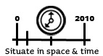  Competencies 1, 2, and 3 | - place facts in chronological order  - place a fact or a set of facts on a timeline  - establish the precedence or posteriority of facts  - situate territories in time  - situate geographic elements or facts or territories in a space at a given point in time.
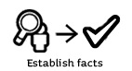  Competencies 1, 2, and 3 | - identify relevant and accurate facts
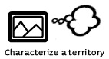  Competency 1 | - identify characteristics
  Competency 3 | - identify similarities and differences
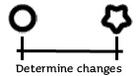  Competency 2 | - indicate a change occurring over time
  Competencies 1, 2, and 3 | - inter-relate facts  - illustrate a statement by citing relevant and accurate facts
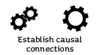  Competencies 1, 2, and 3 | - establish a logical connection between explanatory factors and consequences.
Student Progress

