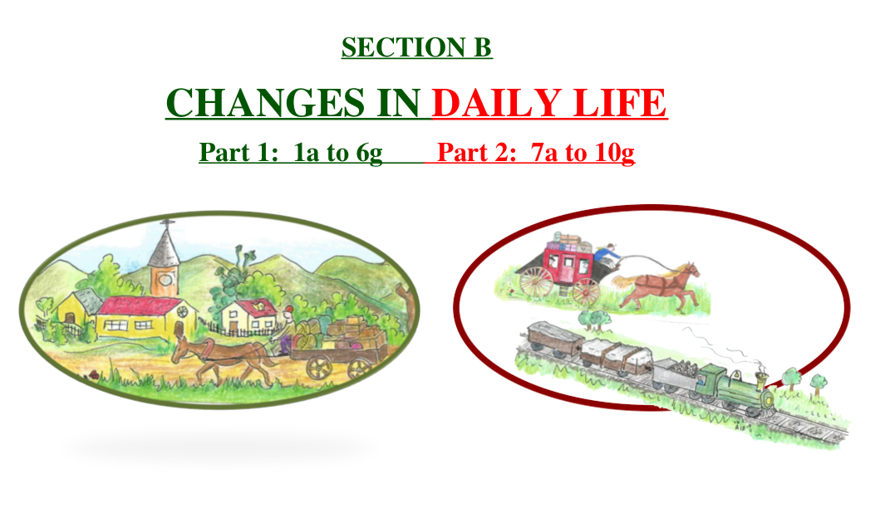

Teacher Guide for Grade 5

SECTION B – TIMES OF CHANGE
COMPETENCY 2  To interpret change in a society and its territory  - To recognize main changes in the organization of a society and its territory  - To establish causes and effects of change  - To justify his/her interpretation of the changes  PoL  Knowledge related to change in a society and its territory  D. Canadian society between 1745 and 1820  a. Indicates changes in the society in the society during this period (e.g. occupation of the territory, presence of Anglophones, lumber trade, canal building)  b. Names groups that played a role in the changes (English merchants and Loyalists)  c. Indicates events that marked this period (e.g. the Conquest, parliamentary government)  E. Canadian society and Quebec society between 1820 and 1905  a. Indicates changes in society during this period: occupation of the territory, industrialization, settlement, railway building  c. Indicates the events that marked this period: Canadian Federation, railway building  I.O.  Situate in time and space; Establish Facts  Techniques  Interprets maps, illustrated documents, tables, diagrams and time lines | 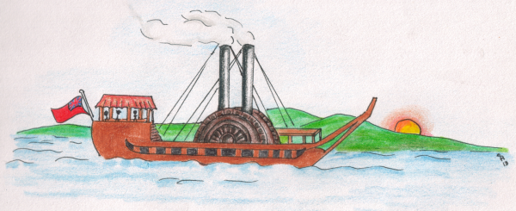  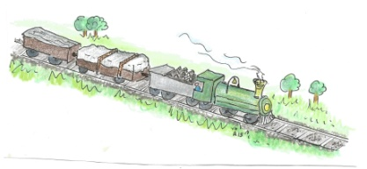

ACTIVITIES: SECTION B
CHANGES IN DAILY LIFE
B1. (a, b) Historical Letters
B2. But Changes Began to Appear
B3. Be the Judge
B4. Changes to the Map of the Province of Quebec (1774)
B5. Who is speaking?
B6. (a, b, c, d, e) Changes in Society – The Loyalists
B6. (f, g) The “Bee” System
B7. (a, b, c) Changes in the Fur Trade
B8. (a, b) Changes in the Timber Trade
B9. (a, b, c) From Business to Industrialization
B10. (a, b, c, d) A Revolution in Transport
B10. (e, f, g) Lachine Canal
B10. (I,j) Steamships and the Railway

SECTION B
Teaching suggestions

Before initiating Section B, start a brainstorming class discussion on what could change after the British conquered New France, and called it the Province of Quebec. It will motivate students to freely express their ideas and thoughts on the topic.

Consider changes that might have occurred:
in the social field
(language, religion, changing of flags, different schools ...)
in the economic field
(agriculture, new industries to feed the British needs...)
in the political field
(different allegiances, military service, a different form of governing...)

SECTION B
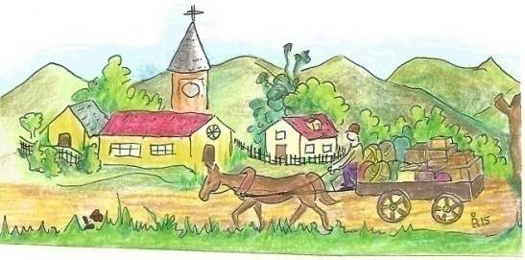
TABLE OF CONTENTS

1. Letters
2. But changes began to appear
3. Be the Judge
4. Changes to the map of the Province of Quebec
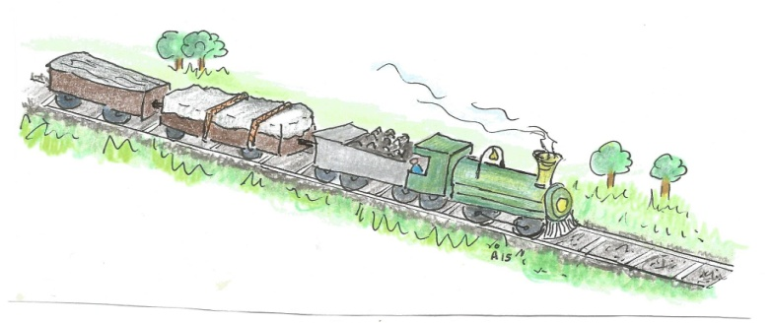
5. Who is speaking?
6. The Loyalists arrive
7. Changes in the fur trade
8. Changes in the timber trade
9. From family business to industrialization
10. Changes in transport

SECTION B1a – Josephine’s letter
Teaching suggestions  After the brainstorming session, students should easily comprehend the historical context and content in which the letters (1a and 1b) were written.  - Consider line 2 and discuss the difference between British and English  (e.g. English is a language or a person that comes from England, the southern part of Great Britain; British is a person that comes from Great Britain which at the time included Ireland)  - To whom is Josephine referring when she writes, in line 2, ``the newcomers``  (She is referring to the British) | Before the Conquest After the Conquest  The name of the colony New France Province of Quebec  The official language French English  The king that governed French king (Louis XIV) British King (George III)  The religion Catholic Protestant

SECTION B1b – Lucas’ reply
Teaching suggestions  Before initiating this activity, discuss with students how difficult it was, in those days, to communicate any information across the province. Obviously Quebec, being the seat of government and center of decisions, was the first settlement to receive and implement new orders, while the country side was the last one. This disparity of time in delivering orders and decisions made for considerable differences on the way the big settlements and the seigneuries embraced and/or reacted to the new order of things. | 1. The seigneurie was too far away from Quebec, the British center of decisions, to feel the change from French control to British control.  2. The British established the new government in Quebec, therefore its inhabitants would experience immediately the demands and impositions of the new way of life.  3. Chemin du roi was a road built, prior to the Conquest, to connect the French settlements along the north shore of the St. Lawrence River.  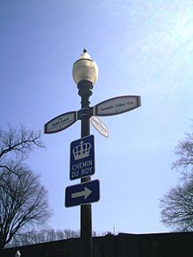  One can still see it for it follows present-day Quebec route 138.  Creative Commons Attribution-share Alike 3.0

SECTION B2 – BUT CHANGES BEGAN TO APPEAR (Act of Quebec, 1774)
Teaching suggestions  Revise with the students the geographical position of Quebec in relation to the Thirteen Colonies, in the south of Quebec along the Atlantic coast.  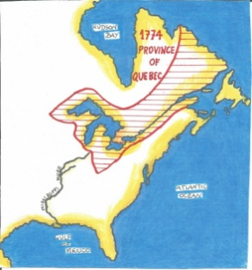 | 1. * Since the Conquest, the French settlers had been barred from working for the government because they were Catholics. According to the Quebec Act of 1774, they acquired the right to apply for any government position they wished.  * Since the Conquest, the French settlers wanted the territory of the Province of Quebec increased.  * They wanted to be governed according to the French Civil Code.

SECTION B3 – THE FRENCH CIVIL CODE AND THE BRITISH CRIMINAL CODE
Teaching suggestions | 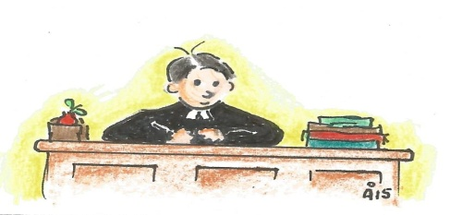  - French Civil Code  - French Civil Code  - French Civil Code  - British Criminal Law  - French Civil Code  - British Criminal Law  - British Criminal Law  - French Civil Code

SECTION B4 – CHANGES TO THE MAP OF THE PROVINCE OF QUEBEC (1774)
Teaching suggestions  The rationale of this slide is for students to practice identifying geographical differences and describing them in the written form. The slide should be first presented for a class discussion. Emphasize the economic importance of the fertile valley of the St. Lawrence River. Assure that students know the geographical position and the names of the Five Great Lakes. Introduce the new region – Labrador, which is today known for its mineral wealth.  Revise with the students the geographical proximity of the Province of Quebec to the American Thirteen Colonies. Students should be made aware that there was a real danger of new anti- British ideas crossing the southern border of Quebec Province.  Around the 1770’s, the British feared the climate was ripe for a revolt in Quebec. They quickly offered the French settlers very favourable conditions in order to keep them satisfied and the British at ease.  Students can then answer the questions independently. | 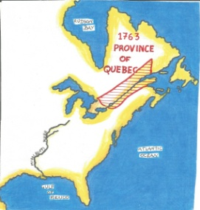  Province of Quebec gained territory:  - on the north bank of the St. Lawrence River,  - around the Five Great Lakes and  - the southern part of the Labrador region.

SECTION B5 –WHO IS SPEAKING?
Teaching suggestions  Students (in groups of 3) should be given 10 minutes to read and discuss the small text in B6. A historical atlas should be used, so that the students become increasingly more familiarized with the territories in question, e.g. The American Thirteen Colonies and the Province of Quebec.  Pose simple questions such as:  - Where were The Thirteen Colonies situated? (Along the Atlantic seaboard)  - Where was Quebec situated in relation to the American Thirteen Colonies? (North of the American Thirteen Colonies)  - Why would the American settlers be interested in Quebec settlers joining them in their struggle against Britain? (The Americans needed all the help they could get, and Quebec was just north of the Thirteen Colonies)  - Why were the French settlers a possible ally of the revolting Americans? (Because French settlers were against British presence in their North America)  - Why did the French settlers have to be disarmed? (Armed French settlers would be danger for British security)  - The Catholic priests had an important role to play, why?  (The French community was Catholic, so the priests could easily influence them.) | 1. The French settler (He had little choice but to promise to be faithful to the British monarch)  2. British soldier (The French settlers had to be disarmed for they could revolt against the British authorities)  3. The American (They were interested in having as many allies as possible in their struggle against Britain)  4. The Catholic priest (He was very influential among the French settlers and could easily persuade them to be faithful to the British monarchy)  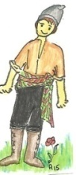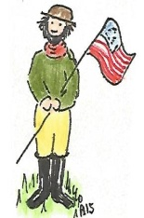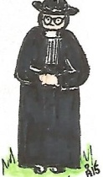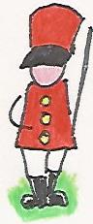

SECTION B6a – THE LOYALISTS ARRIVE
Teaching suggestions  Allow students time (about 5 minutes) to read the text on this slide. Then initiate a class discussion.  Examples: Why were they called Loyalists?  They had remained loyal to the British during the American War of Independence.  - Why would the Loyalists leave their home to come into an unknown region, the Province of Quebec?  They feared repercussions from the Americans because they had been loyal to the British monarchy.  - Where are the Eastern Townships situated in the Quebec Province?  In south-eastern Quebec between the seigneuries south of the St. Lawrence River and the United States border. | 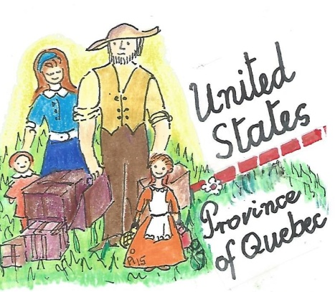  - 1. The Americans viewed the loyalists as traitors to the American cause of independence from Britain.  2. Different ways to distribute the land; a new language, English; new ways of cooking, of dancing; new political ideas more representative of the people’s will...

SECTION B6b – WHERE THE LOYALISTS SETTLED
Teaching suggestions | Any two of the following answers.  i. Most Loyalists did not speak French and the majority of the Quebec population was French speaking.  ii. Most Loyalists did not enjoy living under the French Civil Code which was foreign to them.  iii. The Loyalists did not like the land distribution system, the seigneuries. They preferred the township system which gave them the right to own the land.

SECTION B6c – HOUSING THE LOYALISTS
Teaching suggestions  After projecting this slide, bring to the students’ attention the illustrations depicting the two different systems of land distribution - the French system, the seigneurie, divided into censives, and the British system, the township, divided into lots.  Discuss differences between the two systems:  1. the position of the river  2. the shape of the farms in each system (seigneurie – rectangular and the township more square like)  3. the presence of Crown and Church property in a township (refer to the legend next to the illustration of a Township) and their absence in the seigneurie.  Motivate students to image living in one of the systems. They should then show their preference and give reasons for their choice.  Students should attempt to answer the questions independently. | 1.. Censives are rectangular and the lots are essentially square shaped.  2. All censives had a river front but not so with the lots.  3. There was no Church or Crown land in the seigneuries.

SECTION B6d – CHOOSING A LOT
Teaching suggestions  Students must be made aware that the two illustrations depict the same township. One refers to the possible owners of the each lot, and the other refers solely to the area of the lots.  Then, verbally compare the two illustrations. The students should refer to the legend in order to fully understand the questions.  Example:  * How many lots were owned by the Crown?(2)  * How many lots were owned by the Church? (1)  * How many were left for the new settlers? (17)  *What lots had access to the river? How important was water? ( Lots 4, 5, 8, 9, 10, 12, 13, 14, 16, 17, 18. Water is vital to agriculture. It is needed to water the crops)  Although no drawing was included in the lots at the top of the illustration, they were nevertheless opened for settlers to choose them, if they so wished.  Question iii demands some imagination. Give students some time to discuss it among themselves (in groups of three). A variety of different answers are possible. Accept all those that are backed with sound reasoning. | 1.  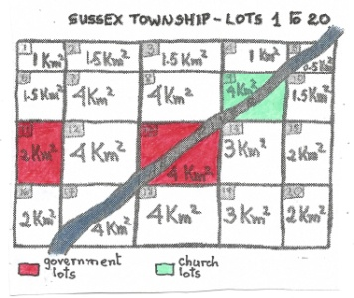  2. Water was easily available. Water is essential to agriculture.  3. For defence purposes because it was situated on the border of the township. A guard post could then be built OR Perhaps no settler would like to be situated between two Crown plots. If no one showed interest in lot 12 then the Crown would acquire it. The Crown would then have acquired a good area for agriculture (lots 11+12+13= 12 km²).  4. Yes, because water is easily available.

SECTION B6e – HELP THE CROMPTONS CHOOSE!
Teaching suggestions  Inform students that there were rules in the distribution of lots. It depended on the number of family members involved.  For instance, in the case of the Crompton family there were 5 members involved (father, mother and three children) and each one of them had the right to a certain amount of land. Once the total area allotted to the Cromptons was calculated, the head of the family could start choosing a lot or lots that amounted to the total area calculated for the family (in this case 3km²).  Allow students, in groups of three, to calculate the total number of km² allowed the Crompton Family, and then expect at least two different options. | First option:  Lot 4 1 km²  Lot 5 0.5 km²  Lot 10 1.5 km²  TOTAL 3 km²  Second option:  Lot 3 1.5 km²  Lot 4 1 km²  Lot 5 0.5 km²  TOTAL 3 km²  Both of the above options allow the Comptons to have access to water. Note that because all lots are adjacent to each other, they all have access to water.  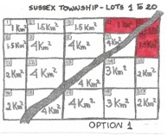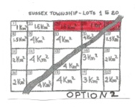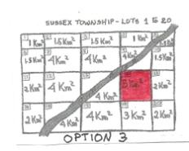  A third option is also offered.

SECTION B6f – THE ‘BEE SYSTEM’
Teaching suggestions  Allow time for students to imagine what tools and materials could have been needed to build a simple, almost primitive, house at the end of the 18th century.  Once the students have completed the activity, they can check their answers by pulling out the tabs. They should then explain orally, the use of each of the tools and materials mentioned in the tabs. | 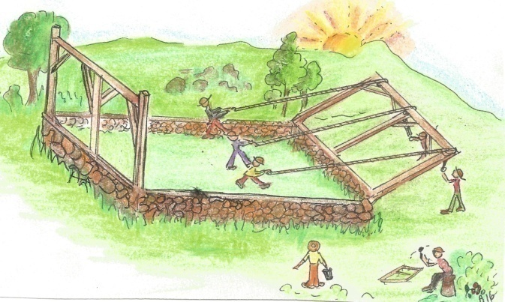

SECTION B6g – MENU AT THE CONSTRUCTION SITE
Teaching suggestions  Students should use as many products as possible from every section of the farm in the illustration. An effort should be made to present a healthy menu according to ‘Eating Well with Canada’s Food Guide’.  www.hc-sc.gc.ca.  It includes translated versions of the Food Guide in 12 languages. | POSSIBLE EXAMPLES  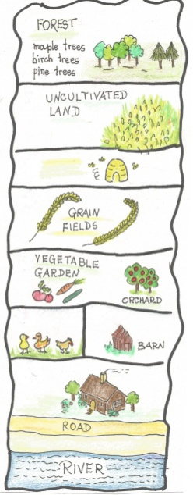  Soup: chicken soup or tomato soup or pea soup or mixed vegetable soup  Main Dish: barbecued chicken or fish or lamb chops or sausages or an omelette, with potatoes and boiled or fresh vegetables  Dessert: salad fruit or apple tart or wild fruits tart  Beverage: herbal tea, apple juice, cider, water  Possible extras: instead of sugar, they could use honey from the apiary or maple syrup

SECTION B7a - CHANGES IN THE FUR TRADE
1. | 2. | 3. | 4.
5. | 6. | 7. | 8.

SECTION B7b - CHANGES IN THE FUR TRADE (continued)
A fox  An otter | 1. The beaver was an animal hunted for its fur.  2. The Natives hunted the beaver and later sold its fur to the settlers.  3. The women were responsible for the tanning of the furs.  4. The coureur de bois bartered with the Natives European utensils for pelts.  5. There was a fur trading station in Tadoussac.  6. The tailor worked hard to make a fur jacket.  7. The store keeper (a furrier) made a lot of money selling fur products.  8. The gentleman is wearing the final product of the fur trade, a beaver hat.

SECTION B7c - SELLING FURS IN 1841
Teaching suggestions  It is important to explain the difference between voyagers and coureurs de bois. The voyagers were hired-hands that transported furs and goods across the province, before and after the Conquest. The coureurs de bois were only active during the French regime. They travelled long distances to barter European goods for pelts from the Aboriginal men.  Since the illustration refers to an 1841 transaction, the European men wearing fur hats must be the voyagers. | 1. The voyageurs transported furs across the Province.  2. Aboriginal women were responsible for the tanning of the furs.  3. The Aboriginal men hunted the furry animals (beaver, otter, fox, mink...).  4. The military men from the fort bought the pelts from the Aboriginal men. In this illustration the Aboriginal women were also present.  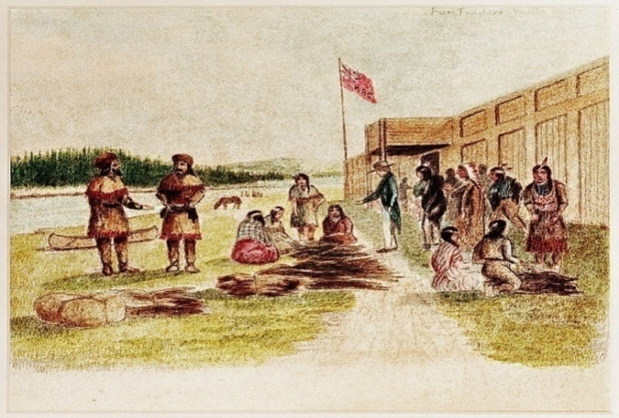  Fur Trading in 1841 Public Domain

SECTION B8a – CHANGES IN THE TIMBER TRADE
1. The ships of the first half of the nineteenth century were made of wood. In the war against the French, Great Britain needed a continuous supply of wood for her ship building. Quebec forests were the source of such wood supply.

2. Wood was also needed for building houses.

3. A lumberjack is a person who cuts down trees.
A log driver is a person that transports logs by floating them down the rivers to the mills.

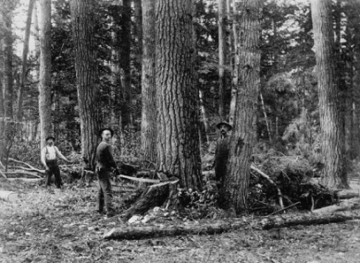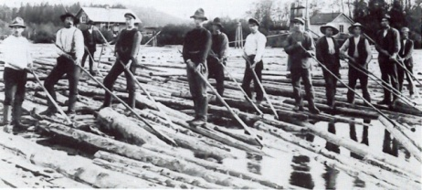

Lumberjacks Log drivers

SECTION B8b - CHANGES IN THE TIMBER TRADE
Teaching suggestions  Remind students of the Basic rules of writing a postcard:  1. Insert the friend`s complete address on the mid-right of the post card.  2. Place the stamp on the upper right hand corner.  3. Address the friend (for example: Hi, Dear or Dear friend...)  4. Give a simple account on how a tree that grew in a forest miles away from the harbour, finds itself in the trunk of a ship on the way to Europe.  5. Consider an appropriate ending.  The answers to this activity can be varied, but they must all include the hazardous work of the lumberjacks and the log drivers. | A simple example:  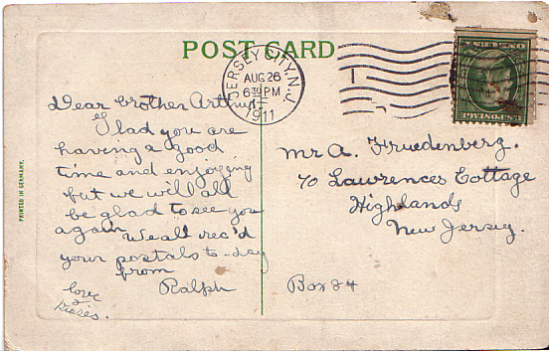  Creative Commons Attribution Share-Alike 3.0

SECTION B 9a & 9b – FROM FAMILY BUSINESS TO INDUSTRIALIZATION
Teaching suggestions
Allow the students, in groups of three, to read and discuss the differences between before and after industrialization. Students should then turn to 9b and write, on the first column, the subject of the difference before completing the table. The first subject is given, only as an example.

An example DIFFERENCES

THE DIFFERENCE IN ... | FAMILY BUSINESS | INDUSTRIALIZATION
- The place of work | At home | In the factory
- The worker’s colleagues | His own family, wife, sons and daughters. | People that he did not necessarily know.
- Part of the final product made by the worker | He made the whole shoe. | He only made one part of the shoe (the sole or the shoelaces or cut only the shoe pattern in leather)
- Selling the final product | He or his wife sold the shoes at the shoe shop. | The factory might have a sales department responsible for the sale of the shoes OR the shoes might be sold to several shoe shops.

SECTION B9c – FAMILY BUSINESS AND INDUSTRIALIZATION
Teaching suggestions | 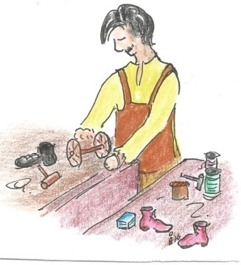  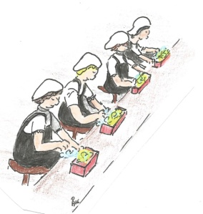  INDUSTRIALIZATION  5, 6, 7, 10  FAMILY BUSINESS  1, 2, 3, 8, 9

SECTION B10a – A REVOLUTION IN TRANSPORT
Teaching suggestions  Before presenting the slide for completion allow students to compare the two means of transport presented, in terms of:  - possible animals used  (A: a donkey or a horse; B only a horse)  - the use and speed of each one  (if a donkey is used in A the speed will be much slower)  Call to the students’ attention the use of carriages as postal carriers (not only letters, but also government or bank documents or money).  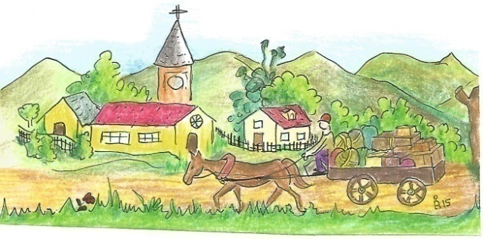 | 1.  A: a cart  B: a carriage  2.  A: used for farm goods , although it could also carry people.  B: used to carry persons, luggage and post  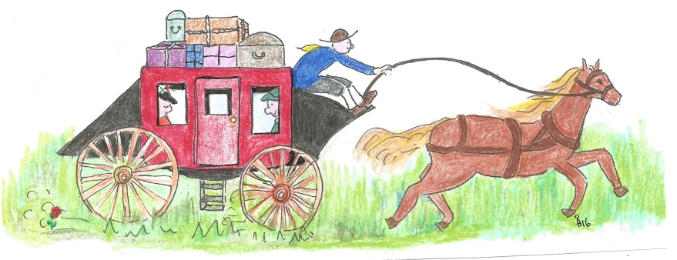

SECTION B10b – A REVOLUTION IN TRANSPORT continued
Teaching suggestions  Students should individually analyze the illustration, and propose possible incidents or discomforts of a stagecoach trip. It is an open invitation to creative thinking.  To further harness their creativity, have a blank poster on the wall. Divide it into two parts, one for incidents and the other for discomforts. The students should write their own sentences on the posters followed by a class discussion.  A second poster for the manager’s responsibilities could also be considered.  Encourage students to contribute with their visuals, if they so wish. | 1.i  Examples of discomforts:  *the bumpy roads hurt passengers’ back  * according to the season, it could either be very hot or very wet inside the carriage  * the trips tended to be too long for comfort  1. ii. Examples of incidents:  * a wheel could fall off forcing the carriage to tilt or even fall sideways.  * the horse could fall due to the state of the road  *a passenger could miss one of the very narrow and bouncy steps of the coach and sprain an ankle  *an attack by marauders was possible  2. i. To establish a time table with appropriate hours of rest for the coachmen and the horses.  ii. To verify that the horses had balanced meals  iii. To supervise adequately the maintenance of the carriage  (the functioning of all mechanisms, the cleanliness, comfortable seats...)

SECTION B10c – A TRIP FROM QUEBEC TO MONTREAL
Teaching suggestions  Explain how the 24 hours of the day are divided into two periods:  A.M. (ante meridiem before midday in Latin) is between midnight 0:00 and midday 12:00.  P.M. (post meridiem after midday, in Latin) is between 12:00 and midnight 0:00) | DURATION OF VOYAGE  FROM TO DURATION (hours)  Quebec Trois Rivières 5:00 am to 12:00 = 7 hr 12:00 to 7:00 pm+ 7 hr Total: 7hr+7hr= 14 hours  Rest period in Trois Rivières 7:00p.m. to 0:00= 5hr 0:00 to 5:00 am= 5 hr Total 5hr+5hr= 10hr  Trois Rivières Montreal 5:00am to 12:00 = 7 hr 12:00 to 6:00pm= 6 hr Total 7hr+6 hr= 13 hr  Duration of voyage from Quebec to Montreal 14 hr+ 10 hr+ 13hr=37hr

SECTION B10d – A TRIP FROM QUEBEC TO MONTREAL continued
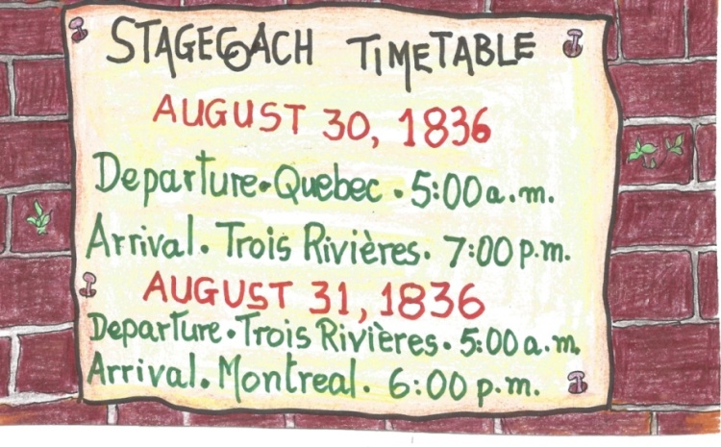  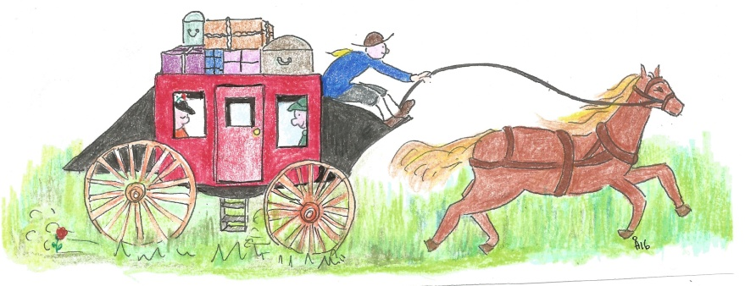 | 1. This trip took place in the 19th century.  2. It was Summer.  3. This trip took place 180 years ago.  4. Today, it takes about 2½ to 3 hours from Montreal to Quebec City by train or by car.  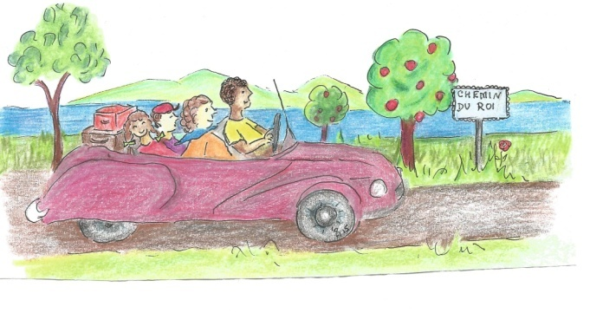

SECTION B10e,f,g – THE LACHINE CANAL
Teaching suggestions  Allow time (± 15 minutes) for students to read the two texts. There certain words that probably are not known to them: portage and tender.  Portage was a place where goods were carried over land due to, in the case of the Lachine Canal, the rapids that made navigation so dangerous.  Make a tender is an offer to execute some work.  Lead students to realize that photo no.3 is irrelevant to the question for it was taken in 1920, well after Redpath had the Canal built.  Lachine Canal underwent a series of improvements and continued to operate until around 1950. It was then replaced by the St. Lawrence Seaway. | THE LACHINE CANAL PROJECT PROPOSAL  TITLE OF PROJECT Lachine Canal  PROJECT START DATE July 1821  PROJECT END DATE 1825  NAME OF PROJECT MANAGER John Redpath  CONTACT NUMBER Any number  PROJECT DESCRIPTION – The canal will run for 14.5 km from Old Montreal to Lachine Locks (with a width of ± 12 to 13 metres)  COMMUNITY BENEFITS  1. The ships will no longer have to face the rapids. Navigation will be safer.  2. Portage will be eliminated.  3. Shipwrecks will diminish considerably.  4. It will make travelling much more comfortable.  5. It will attract many industries (specially wood, steel, wood, garments and leather)  6. It will make Montreal a thriving trade center.  7. It will open many new employment opportunities.  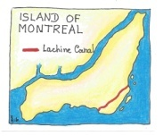  Signature (Project Manager) John Redpath  ADD PERTINENT PHOTOS TO THE PROPOSAL

SECTION B10h and B10i – A REVOLUTION IN TRANSPORT continued
Teaching suggestions
Allow students to consult atlases, so that they can situate all the geographical positions mentioned in this slide. Point out the strategic situation of Montreal. The St. Lawrence River links Montreal to the Great Lakes in the east, and to the Atlantic Ocean in the west. The building of the railway line from Montreal to Portland, an ice-free port on the Atlantic coast of USA, would increase business to two markets: the American and the European.

10h
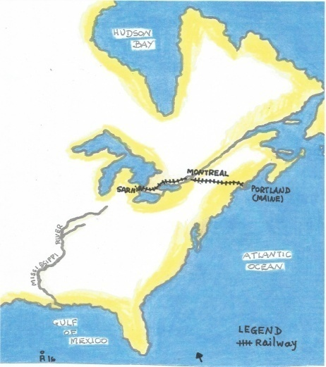
1. Steam energy
2. Wind energy
3. Steam energy

10i Question 1
see map at right

10i Question 2 – Montreal was able to sell the output of its industries to the West (the Prairies) as well as to USA. It soon became one of the most thriving trade centres in North America.

