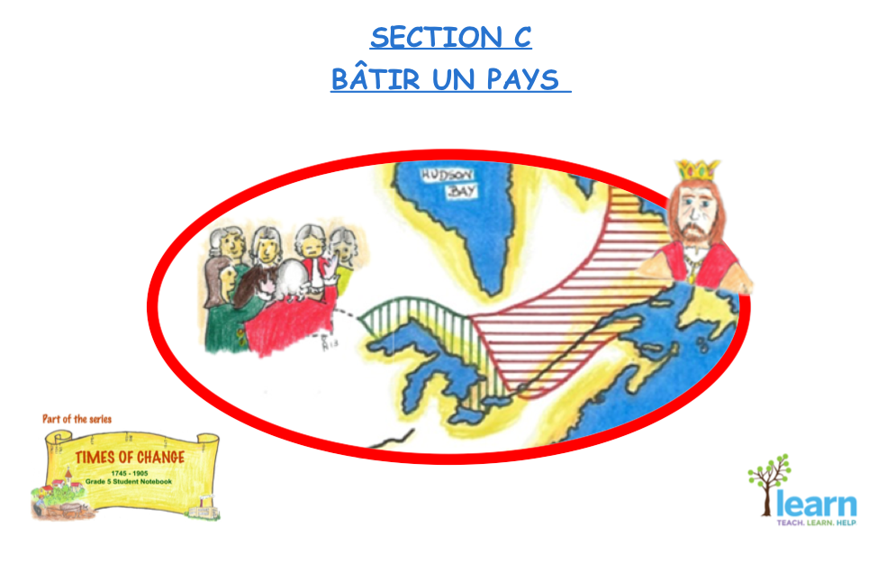
Teacher Guide for Grade 5

SECTION C – THE GOVERNMENT
Competency 1  To understand the organization of a society in its territory  - Defines the influence of events on social and territorial organization | 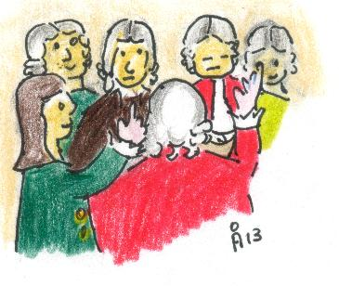  The government  The people  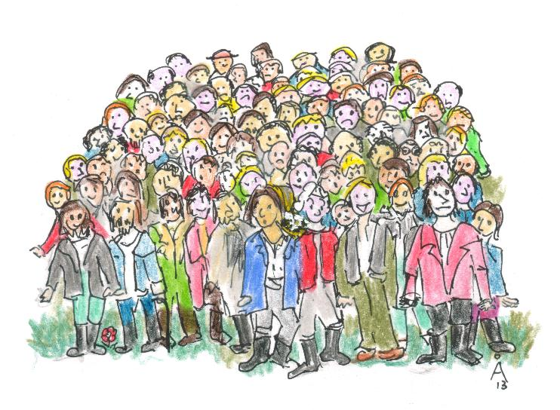
Competency 2
To interpret change in a society and its territories
- Defines the influence of people or events on those changes
- Makes historical comparisons
- Determines explanatory factors and consequences
PoL
E. Canadian society in space and time
1. Location of the society in space and time
b. Situates, on graduated time lines with different scales, events and people related to the history of the society
2.4 Political situation
a. Indicates the means of selecting leaders: the king of England appointed the governor and the people elected representatives
b. Indicates the means of decision making: the representatives passed the laws and the governor approved or vetoed them
c. Names an institution: the House of Assembly
IO
Characterizes a territory
Situate in time and space
Establish causal connections
Make comparisons
Technique
Interprets illustrated documents
Interprets tables

ACTIVITIES: SECTION C
CHANGES IN THE WAY OF GOVERNING

C On government in general
C1. Upper and Lower Canada
C2. A Little Atlas
C3. Differences between Upper and Lower Canada
C4. The Government of Lower Canada (1791)
C5. Members of the Government
C6. (a, b, c, d, e) Fictitious Scenarios
C7. A Voting Scene in the 18th Century
C8. How Representative was the Government?
C9. Newspaper Project
C10. An Unhappy World – The Rebellions in Lower and Upper Canada C11. The Leaders of the Rebellions
C12. The Demands of the Rebellion Leaders
C13. (a, b, c, d, e, f) The Rebellion
C14. Your Thoughts
C15. The Union Act (1840)
C16. The Settlers and the New Assembly
C17. Who is not mentioned
C18. The Founding Provinces of the Canadian Federation (1867)
C19. Who is Responsible for what in the Canadian Confederation?
C20. Who is Responsible?
C21. Canada Today
C22. A Timeline
C23. Who Joined in the 20th Century?

SECTION C – THE GOVERNMENT - THE MAKING OF A COUNTRY
Teaching suggestions  The concept of government is not easily grasped by grade 5 (Cycle 3 year 1) students. It is advisable to initiate a class discussion on its concept so that through the exchange of ideas, students become aware that a society needs a government in order to be functional.  A government passes laws (legislative branch) and implements laws (executive branch), so that a harmonious society is established. Emphasize the fact that differences of opinion will always exist, but such differences must be respected and laws have to be passed by the government to ensure that respect is maintained.  As an example, refer to the election of the class representative. Point out why it is relevant for student views to be heard in an organized and respectful manner. Discuss also the principle that one should not vote for an individual because he/she is an acquaintance or a friend or a powerful person, but rather because he/she will do what is expected by those who elect them. | Explain also, that today a democratic government has three branches :  -the executive branch, takes the decisions (Prime Minister and his Cabinet)  -the legislative branch, makes the laws (Parliament)  -the judicial branch, interprets and applies the laws (judges and courts)  What students are going to learn in Section C, is one of the first attempts at creating a government with both executive and legislative chambers in Lower Canada and Upper Canada (1791).  The visuals and the activities should lead the student towards an understanding of the role of government within the evolving societal context of this British North American Colony that later became known as Canada.

SECTION C - THE GOVERNMENT
THE MAKING OF A COUNTRY
Teaching suggestions  Initiate a discussion on:  - The type of place the illustration depicts  - The type of activity that is being held  - The type of male clothing of the times compared with today’s (trousers, coats, wigs)  For all of the above the students have to support their opinion with evidence present in the illustration.  Introduce the words below under the title Words to Know, so that students become familiarized with pertinent words for Section C.  Words to know:  Ballot, executive, government, governor, judicial, jurisdiction, king, legislative , motion, parliament, settlers, taxes, veto | 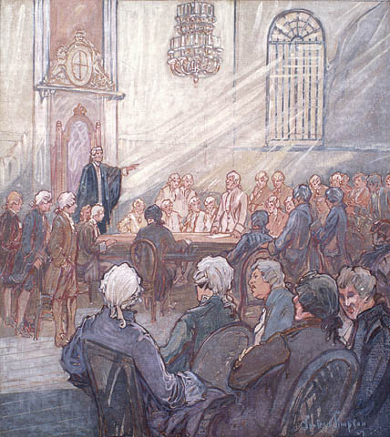

SECTION C1 – THE GOVERNMENT
UPPER CANADA AND LOWER CANADA (Constitutional Act 1791)
Teaching suggestions  Before starting activity C1, discuss with the students the meaning of the word ‘parliament or ‘legislative council’. Parliament is where the laws of a country are made. Nowadays, all members of parliament are elected by the people, but that was not the case in the 18th century.  The British settlers in Upper and Lower Canada were demanding a parliament like the one the British had in Great Britain. | 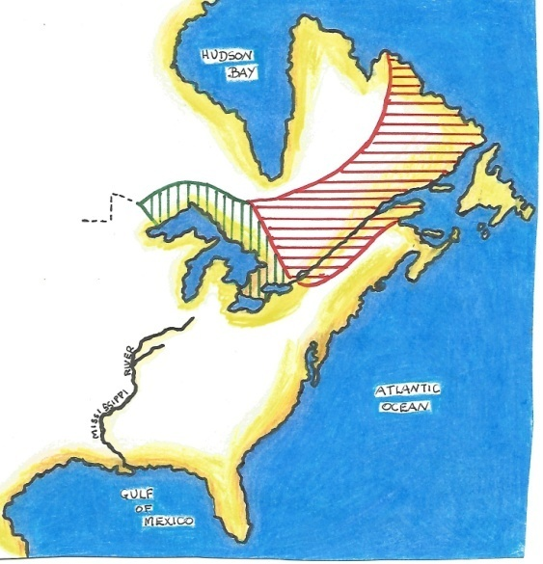  UPPER CANADA and LOWER CANADA  2  1791  1. The British colonists were dissatisfied because they thought the French, the ‘conquered’, were being given the same rights as themselves, the British, who were the “conquerors”. The French were satisfied, because they would continue to live in a French environment (culture, language, religion, etc.)
‘

SECTION C2 – GOVERNMENT - A LITTLE ATLAS
Teaching suggestions to identify maps  MAP 1 - 1760 NEW FRANCE.  Maps of New France just before the Conquest, stretched from the St. Lawrence to around the Great Lakes, down along the Mississippi River to the Gulf of Mexico.  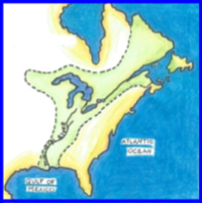  - MAP 2 – 1763 PROVINCE OF QUEBEC  French settlers were reduced to a narrow strip on the north and south bank of the St. Lawrence River.  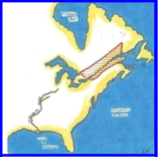 | - MAP 3 – 1774 PROVINCE OF QUEBEC  The British, fearing French settlers would join the American revolutionaries, decided to enlarge their territory right around the Great Lakes and part of Labrador.  - 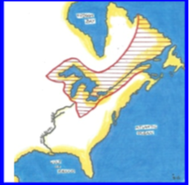  MAP 4 – 1791 UPPER CANADA AND LOWER CANADA Refer to slide (C1).  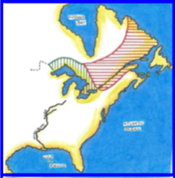

C3 - THE GOVERNMENT - DIFFERENCES BETWEEN
UPPER CANADA AND LOWER CANADA
Teaching suggestions  This activity allows students to identify differences (language, religion, laws, and land distribution) between the British and the French settlers. | 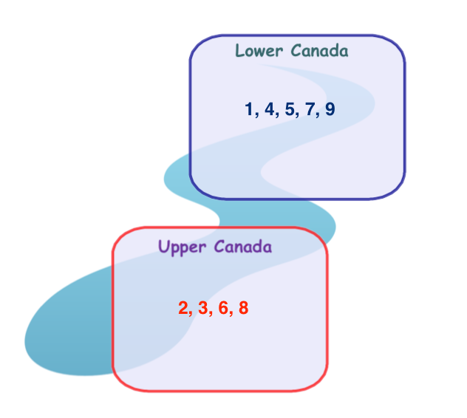

C4 – GOVERNMENT OF LOWER CANADA 1791
Teaching suggestions  Although far from being a Parliament as we know today, the Government of Lower Canada (1791) was the first attempt at establishing some form of representation (House of Assembly) on Canadian soil.  Call to the students’ attention the fact that the House of Assembly was the only elected body of government. Hence the French seats in the House of Assembly were double the number of British seats, because French settlers were double in number to the British settlers.  However, in the Legislative Council, where the members were nominated, and not elected, the French settlers were a minority. For the same reason the French settlers were also a minority in the Executive Council. | 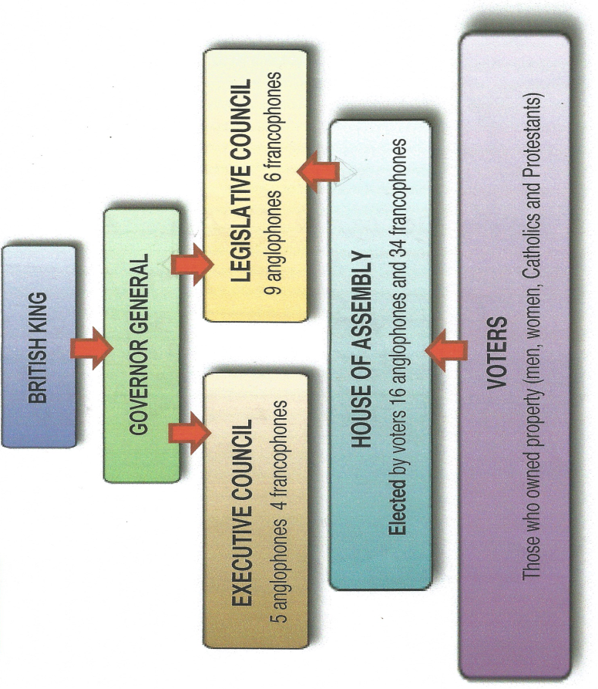

C5 - MEMBERS OF THE GOVERNMENT
Teaching suggestions  Students have already analyzed this illustration. Ask them now what possible body of government does the illustration portray. It is probably, the House of Assembly for that is the body of government with most members. Yet, it could also be a joint meeting of both the Executive and Legislative Councils. Difficult to be precise, but it is an attempt at interpreting an illustration. | 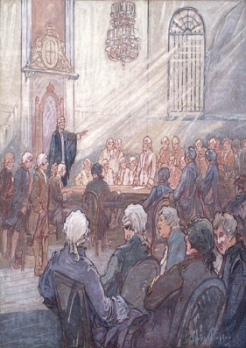  - Because members of the House of Assembly were elected, and the majority of the population consisted of French settlers (voters).  2. (Accept positive and negative answers in so far as the student backs them with evidence.)  No, because if I, the Governor General, gave the same number of seats to both the French and British settlers, the colony would be faced with a government representing more French than British settlers in a British Colony. OR  Yes, as a Governor General, I had to face the reality of the population, and allow for a French majority in both the Legislative and Executive Councils.

C6 – THE GOVERNMENT - FICTITOUS SCENARIOS (Scenario A)
Teaching suggestions  C6 consists of five (a to e) different historical situations. Each activity should help students connect historical events, often too abstract for a young mind, to everyday happenings.  Initiate a discussion on the definition of the word, king (queen or monarch) particularly in the 18th and 19th century.  Pose the following questions:  * How did a person become a king? It was hereditary; therefore, the oldest male offspring would succeed the father. There were exceptions, where women also ascended to the throne, like Queen Elizabeth I.  * What powers did a king have? He had all powers and no one could contest his actions and decisions.  * Over which territories could a king exercise his powers? The king exercised his powers over all territory that belonged to his kingdom.  One can then conclude that the king was an ‘absolute king’ because he had absolute power. However, slowly parliament, the elected body of government, began to demand more powers from the king. Eventually, the king became more of a figurehead with little or no political power, and is then called a ‘constitutional monarch’ because he has to rule according to a constitution. | 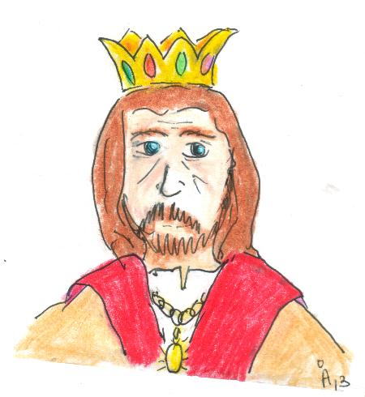  i. The king’s order would be sent to the Governor General.  ii. Then the Governor General would send the order to the Executive Council.  iii. The Executive Council would inform the harbour authorities to apply the King’s order to all ports of the colony.

C6 – THE GOVERNMENT - FICTITOUS SCENARIOS (Scenario B)
- The King’s order would be delivered to the Governor General who would send it to the Executive Council.
- The Executive Council would then instruct the harbour authorities to apply the king’s order.
Teaching suggestions  - Before starting the activity, discuss the meaning and purpose of taxes for a community. It is important that the students understand that a government collects money (taxes) from its citizens to pay for various activities shared by all such as schools, hospitals, the military ...  - Ask students to give other examples (police, roads, bridges, public transport, water and waste management...)  - Allow students to read, for about five minutes, the very short story of Scenario B.  Students should then be asked to retell the story without using the word taxes.  - Students should be allowed to consult the government structure found in C4. | 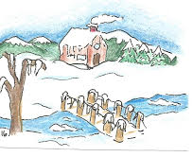  - To the House of Assembly  - Yes, because the farmers produced most farm goods that fed the community, so they deserved to be helped when in difficulty.  - To the Legislative Council  - To the Governor General  - The motion would be dropped.

C6 – THE GOVERNMENT - FICTITOUS SCENARIOS (Scenario C)

Teaching suggestions  - This activity allows for a very simple introduction to ‘women issues’ in Quebec. It is but an example of how women were barred from participating in political issues of importance for the province.  - True to say that in 1791 women were allowed to vote, if they owned property, but even this was withdrawn in 1849. They were to regain the right to vote only federally in 1918.  - Women had to wait until 1944 to obtain the right to vote in Quebec provincial elections!  - Possible questions (first write on the board the most important dates, and their meaning, in women’s struggle to acquire the vote - 1791, 1849,1918, 1944 (see above); then pose the following questions:  - Could women vote in 1801? (No) in 1901? (No) in 1921? (Yes, in federal elections only) 1948? (Yes, in federal and provincial elections).  - What reactions, do you think, women had to such discrimination? Some women opposed discrimination of women, but others actually thought that a woman`s place was in the home and not in politics. | 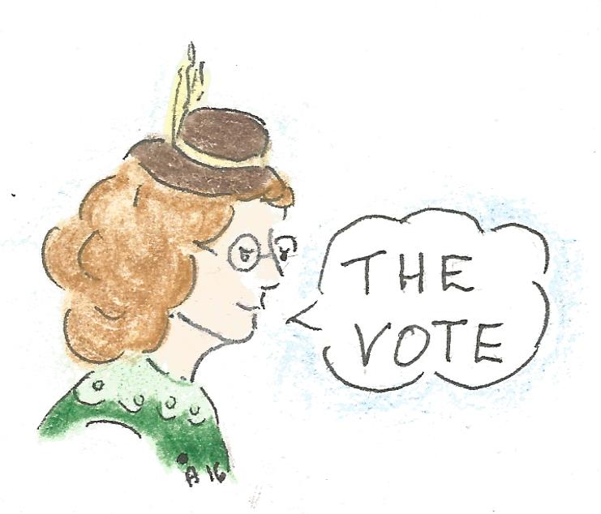  1. The House of Assembly.  2. No, because both the community as well as those in authority thought a woman’s place was in the homestead and not in politics.

C6 – THE GOVERNMENT - FICTITOUS SCENARIOS (Scenario D)
Teaching suggestions  Child labour has always been an issue in most societies. In Canada, it was only in the 1920’s that laws were passed to protect children from exploitation. Sixteen is today’s minimum age for employment.  Initiate a discussion on the issue of child labour.  - The type of work where children were exploited (mines, factories and farms)  - The type of work children performed that was harmful to their physical and mental health (carried heavy loads, paid well below minimum wage, forced to work long hours, worked in harmful environments e.g. mines; were brutally punished for small infractions)  Allow students to refer to C4 to revise the government structure. | 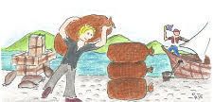  - The Legislative Council and be sanctioned by the Governor General.  - i) It had to be approved by the Governor General who would then pass his approval to the Executive Council.  ii) The Executive Council would be responsible for the law to be executed throughout the colony.

C6 – THE GOVERNMENT - FICTITOUS SCENARIOS (Scenario E)
Teaching suggestions  Revise C4 again so that students become quite cognizant of the government structure in the 18th and 19th centuries and complete this activity. | 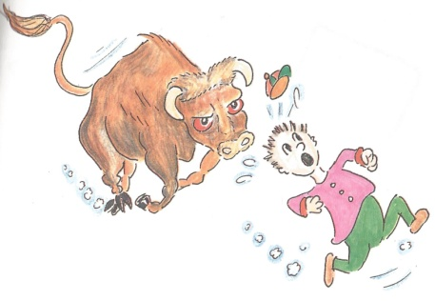  i. Legislative Council  ii. Governor General  iii. Executive Council

C7 – THE GOVERNMENT - A VOTING SCENE (18TH CENTURY)

Teaching suggestions  Initiate a class discussion on:  - The meaning and responsibility of the right to vote  - The meaning and importance of secret voting or secret balloting  - The meaning and importance of election scrutinisers.  Another topic that deserves to be considered is attire. One can ask students to deduce, from evidence present in the illustration, the social status of each individual.  Examples:  The second man from the left appears to be a labourer, he is wearing boots, and a shirt without a coat; but the third man has a wig and his whole attire, frock coat in particular, leads one to assume he was a noble or moneyed individual. The last two individuals are wearing vests and socks, and their shirts appear to be of a better quality than the second man from the left. They might be professionals (clerks, secretaries or footmen). Compare the woman’s clothes with today’s fashion. | 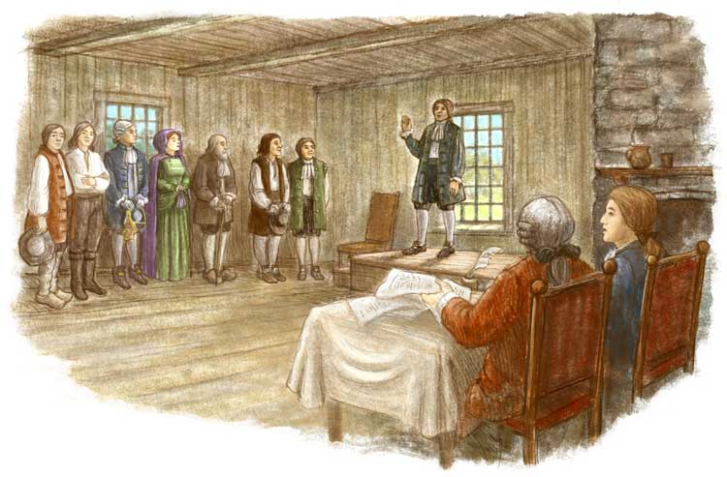  1.  - Because only women, who were property owners, had the right to vote.  - Labourers, moneyed-class, and professionals (doctors, lawyers or teachers)  - They were voting for the House of Assembly because it was the only body of government that was elected, the others were nominated.

C8 - HOW REPRESENTATIVE WAS THE GOVERNMENT?
Teaching suggestions  Discuss with students the need for a government to represent the will of the people, if it wants to call itself a democratic government. Such a government creates an atmosphere of peace and well being among its inhabitants. This is what section C is mostly dedicated to.  Of course, a democratic government was not achieved in the 18th and 19th century, but at least attempts were made which became the springboard to further the quest of representative government in Canada. | - No, because the House of Assembly had little or no power of decision-making. Furthermore, decisions taken by the Legislative Council and the Executive Council could be vetoed by the Governor General.  - No. They were only proportionally represented in the House of Assembly, in the other two bodies of government, Legislative and Executive Councils, they were not.  - A variety of different answers are possible. Two examples:  - I would give more decision power to the Legislative Council so that laws would represent more the wishes of the people.  ii. I would eliminate some powers of the Governor General, so that the settlers could have more say in the way they were governed.

C9 – THE GOVERNMENT - NEWSPAPER PROJECT
My Name:_______________________ My Partner’s Name: _________________________
Date: _____________ Class: ________________
WHO is dissatisfied with the government of the colony? | TITLE OF THE ARTICLE | WHAT should the British government do to improve the situation, and make the settlers more content?
WHY are they so dissatisfied? | TITLE OF THE ARTICLE | If no changes take place, WHAT might happen?

Do not forget to include illustrations, they appeal to readers. However, they have to be relevant to your text. Once the table is completed, write your newspaper article with logical clarity of thought and back your case with examples (if you so wish, you can use the cases in the activities you have just completed.

C 10 - AN UNHAPPY WORLD - THE REBELLIONS IN LOWER CANADA AND UPPER CANADA (1837-1838)
Teaching suggestions  Initiate a discussion on how elected and nominated members of government influence the degree of representation of the will of the people.  Compare with a situation where the teacher chooses (nominates) a few students to do some task, while another teacher elects students on the basis of a small class election where every student, girl or boy casts his/her vote. | 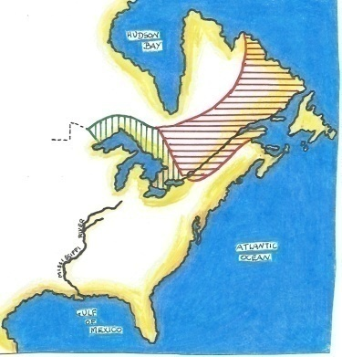  - Elected were those that were chosen through the voting process (House of Assembly members).  Nominated were those who were simply chosen for the post (Legislative and Executive Council members).  - Because those in government (Legislative and Executive Councils) had been chosen and not voted by the people. Therefore, they could not represent the people’s wishes.

C11 – THE LEADER OF THE REBELLIONS
Teaching suggestions  A student-friendly book on the topic and well illustrated:  Rebellions, Don Quin, (2005) Canada. A People History, Fitzhenry & Whiteside.  Allow students to consult the Internet on the two main rebellion figures:  1. Louis-Joseph Papineau  http://blogdev.learnquebec.ca/societies/societies/lower-canada-around-1820/louis-joseph-papineau/  www.canadahistory.com/sections/eras/reform/louis_jseph_papineau.htm  www.thecanadianencyclopedia.ca/en/article/louis-joseph-papineau/  www.britannica.com/biography/Louis-Joseph-Papineau  2. William Mackenzie  www.thecanadianencyclopedia.ca/en/article/mackenzie-william-lyon/  www.britannica.com/biography/William-Lyon-Mackenzie | 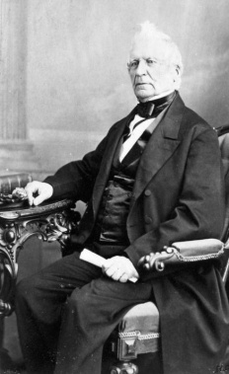  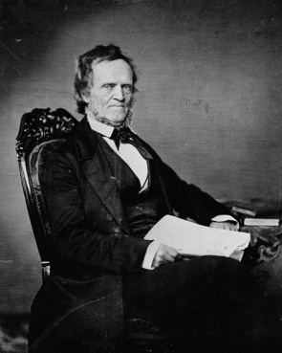

C 12 – THE DEMANDS OF THE REBELLION LEADERS
Teaching suggestions  Question 1 has to be answered considering the political aspect and then the economic one.  Political aspect  Call to the students’ attention that both Mackenzie and Papineau were demanding a more representative government, where the will of the people would be heard and considered.  Economic aspect  Explain how important the economic factor is for a country. Compare the situation of a family that has only one member earning a very small salary. Poverty can set in. Likewise, a government can see its revenue reduced because nobody buys its country’s products. | - i. Both Lower and Upper Canada voters wanted to be heard by government officials, but they were not listening.  ii. One of the most efficient ways to hit back at Britain was not to buy the British goods that were shipped to Lower and Upper Canada. Such goods were a great source of money (taxes) for the British government and for British merchants (high profits)  - The French settlers’ demands were based on the recognition of the French language, more French people in government and the continuation of the seigneurial system. The Anglophones’ demands were more related to freedom of worship and shorter working hours for the labourers.

C 13 - THE REBELLION - Scenario A - Contacting the supporters
Teaching suggestions  C13 consists of six (a to f) different historical situations. Each activity should help students connect historical events, often too abstract for a young mind, to everyday happenings.  Scenarios A and B need to be dealt with in sequence. They depict two different moods of the Patriotes. In A, the crowd appears to be vibrant, cheerful, and in agreement with the speakers. Yet, the mood changes in B, when the reality of war sets in. The poor war equipment and the lack of proper battle training must have concerned them. Nevertheless, these fighters faced with bravery all odds of warfare (the majority was French but there were also Scottish and Irish fighters). | 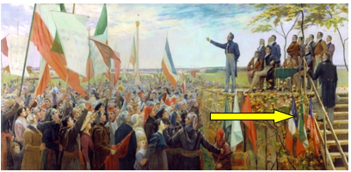  1. Because most French settlers lived in the countryside.  2. The mood appears to be one of joy.  3. i. American flag – The Americans were popular because they had revolted against the British.  ii. French flag – The flag of their country of origin  iii. Flag of the Patriotes – the flag of the rebels

C 13 - THE REBELLION - Scenario B - Preparing for war
Teaching suggestions  Before starting the activity, allow students to discuss the illustration in terms of war readiness (‘uniform’ and weaponry).  It should be followed by a discussion in terms of what would be the foreseeable outcome of the rebellion with an army so poorly equipped, although they knew the terrain better than the British. | 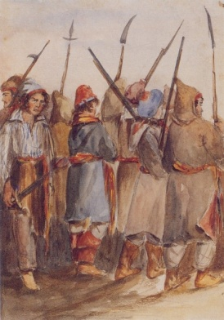  1. The “people” were essentially French settlers from the country side, although there were also some Scottish and Irish.  2. They were poorly equipped as they seem to have only bayonets and no uniforms adapted to warfare.

C 13 - THE REBELLION - Scenario C - The skirmishes

Teaching suggestions  Allow students to initiate a discussion on the position of the two armies – the Patriotes and the British. The British are positioned on the right bank of the river and the Patriotes on the left bank.  Possible questions:  *What caused the two trees to fall down? (Are the British trying to build a precarious bridge that will allow them to advance to the other side?)  * Who has the better position, the British or the Patriotes? The British have divided themselves into two groups. One group is fighting in the background while the other in the foreground appears to be on standby in case of need. The British are by far more numerous but even so, the Patriotes appear to be offering strong resistance.  * What role does the river play in this battle? At least temporarily, it divided the two camps and acted as a line of defence against the British. | 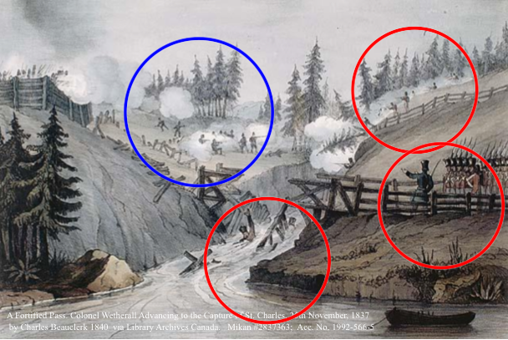  2. The Patriotes destroyed the bridge to avoid the British advancing to the Patriotes` position.  3. Answers can vary. Some examples:  * The broken bridge and the two British soldiers (identified by their hats) struggling with the current.  * The well equipped British soldiers pounding at the Patriotes.  * The barrage of firing in the background but not so in the foreground.  * The battle takes place in the countryside which is usually a place of tranquility.

C 13 - THE REBELLION - Scenario D - A Victory

Teaching suggestions  Before starting the activity, allow students to discuss the illustration of the battlefield.  Some suggestions for the discussion:  the position of the British soldiers and the Patriotes; the season of the year depicted; the implications and problems such a season would bring to the battlefield; the reason for the presence of a drummer; the location of the battlefield; the weapons being used; who is lying on the ground, a British Soldier or a Patriote (the hat identifies him as a Patriote, and he is in front of the British lines of attack).  Students should then individually answer the questions of scenario D. | 1. 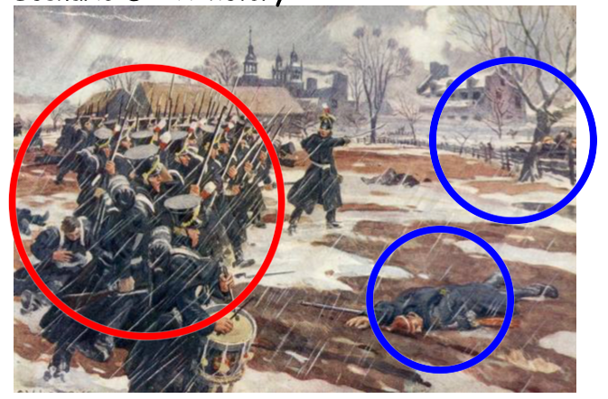  2. The British are charging against the Patriotes who are hiding behind the fence.  3. I would have given the soldiers time to rest before engaging in battle. After all, they had walked all day in difficult weather conditions.

C 13 - THE REBELLION - Scenario E - The British determined to crush the Patriotes
Teaching suggestions  Before starting the activity, allow students in groups of three, to study the two illustrations.  Some suggestions for the discussion:  The location of the battle in A; the position of the British soldiers and the Patriotes in A and B; the weaponry being used; the position of the British artillery in A; the position of the British first aid to their soldiers in A; the typical British formation in both A and B... | 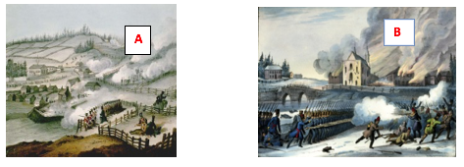  A. The British are pounding, not only the Patriotes on the hill, but also the village.  B. The British have bombarded the village (houses burning in the background) and are charging towards the Patriotes in the foreground. The bridge, heavily guarded by British soldiers, is of strategic importance as it is the entrance/exit to/from the village.

C 13 - THE REBELLION - Scenario F - The end of the rebellion
Teaching suggestions  Allow students for about 10 minutes, to discuss what is happening in the illustration. They should be able to identify the soldiers, the crowd, and those about to be hanged. Students could also extrapolate that the scene takes place just after the rebellion ended.  Students should also identify those in the foreground (the mob, bottom left, lined by soldiers and the same configuration on the right middle ground). | 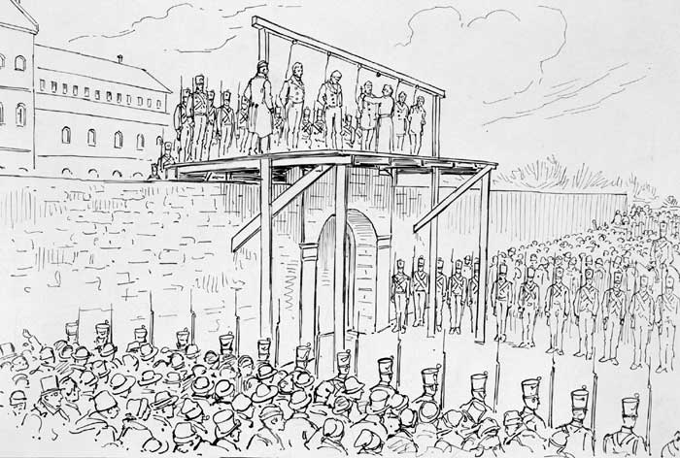  1. Because the village and/or the remaining Patriotes could suddenly revolt against seeing their brothers-in-arms being hanged.  2. They could have been sent to prison and forced to do public works such as building roads, hospitals and schools, or help farmers in their demanding field activities. They could have also been deported.

C 14 - YOUR THOUGHTS
Teaching suggestions  This slide is dedicated to those who enjoy more advanced activities. They are expected to consider each demand of the leader of the Patriotes, Louis-Joseph Papineau (refer to C12), and attempt to imagine what he would have done if his cause had triumphed. The students can ponder whether L.J. Papineau, a seigneur, would be willing to extend the right to vote to the lower income group of French and British settlers.  Accept different answers, in so far as the student proves his/her case with historical data. | ?

C 15 – THE UNION ACT OF 1840
Teaching suggestions  Explain to the students how simple the question really is. It is obvious that if the Upper Canada and Lower Canada were to be united, then all they have to do, is to join the two territories into one. | UNITED CANADA 1840  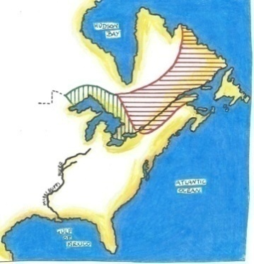  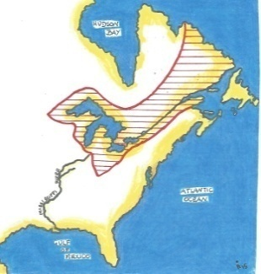

C 16 – THE SETTLERS AND THE NEW ASSEMBLY
Teaching suggestions | The Union Act (1840) displeased the British settlers because they did not want the Catholic French settlers to participate on an equal basis in government. The French settlers were viewed as the ‘conquered’ and as such should not have the same political rights as the British.  The Union Act (1840) would displease the French settlers because they did not want the British settlers, who were less numerous, to participate in government on an equal basis. Also because the British were Protestant, and at the time there was still much religious resentment between the two religions.
  Territory | Population | Seats in the  Assembly | Language of the majority | Religion of the majority
  Lower Canada | 650 000 | 42 | French | Catholic
  Upper Canada | 450 000 | 42 | English | Protestant
  TOTAL | 1 100 000 | 84

C17 – WHO IS NOT BEING CONSIDERED?
Teaching suggestions  European colonial powers (Great Britain, France, Spain and Portugal) never considered the natives of the territories they conquered and settled in, on a par with the settlers. Natives were marginalized throughout the colonial era, which lasted well into the 20th century.  Their marginalization was political, economic, and social.  Yet the natives taught us much. This activity is but a simplistic attempt at making the students aware of native contribution to European life in the British North American colonies. | sNow shoes  mAize  Tobaggan  bIrch canoe  beaVer  teepeE  lacrosse

C18 – THE FOUR FOUNDING PROVINCES OF THE CANADIAN CONFEDERATION
Teaching suggestions  Ask students to compare the boundaries of the four Founding Provinces to present day boundaries.  (Today, both Quebec and Ontario provinces have a much larger territory, while New Brunswick and Nova Scotia have remained considerably the same) | 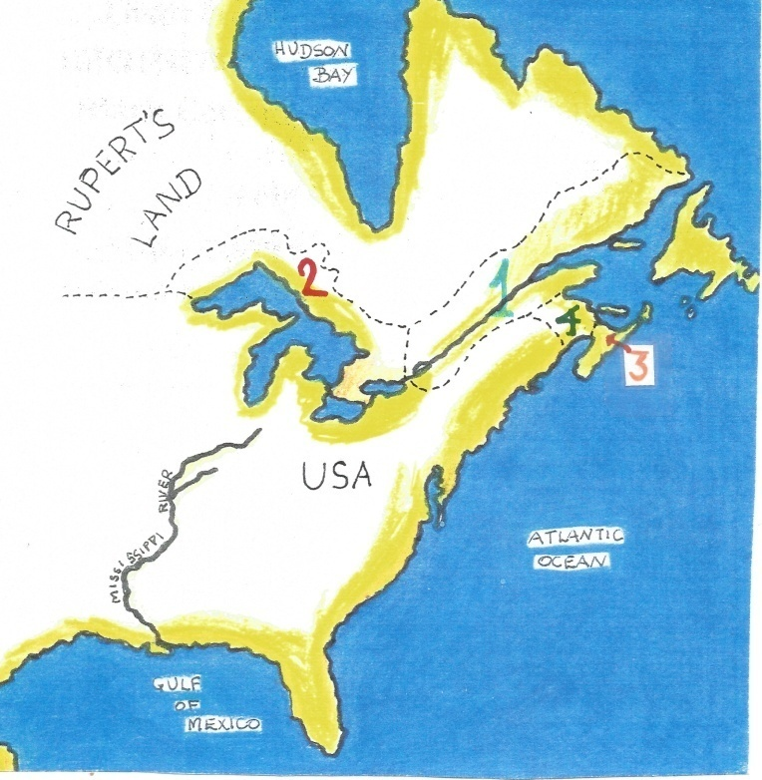

C19 – WHO IS RESPONSIBLE AND FOR WHAT IN THE CANADIAN FEDERATION?
Teaching suggestions  Students should understand that all matters between provinces (interprovincial) and international dealings fall under the jurisdiction of the Federal government, while matters related solely to the specific province fall under the jurisdiction of the provincial governments. | FEDERAL GOVERNMENT  1, 3, 4, 6, 8, 10  2, 5, 7, 9  PROVINCIAL GOVERNMENT

C20 – WHO IS RESPONSIBLE?
Teaching suggestions  This activity attempts at helping students connect the division of jurisdictions (federal and provincial) to everyday experiences. It should make matters more tangible, hence less abstract.
  1 | F
  2 | P
  3 | P
  4 | P
  5 | F
  6 | P
  7 | P
  8 | F
  9 | F
  10 | F

C21 – CANADA TODAY
Teaching suggestions  Allow students to consult atlases, if they so wish.
  Alberta | 9 | Manitoba | 7 | Newfoundland | 1
  Nova Scotia | 2 | Ontario | 6 | Quebec | 5
  British Columbia | 10 | New Brunswick | 3 | Northern Territories | 12
  Nunavut | 13 | Prince Edward Island | 4 | Saskatchewan | 8
   |  |  |  | Yukon | 11

C22 – A TIMELINE
One may explain to students the difference between a Province and a Territory.  A PROVINCE – receives its powers and authority from the Constitutional Act (1867).  A TERRITORY – receives its powers and authority from the Federal government in Ottawa.
  1867 | NB, NS, ON, QC
  1870 | MB, NT
  1871 | BC
  1873 | PE
  1898 | YT

C23– WHO JOINED IN THE 20th CENTURY?
