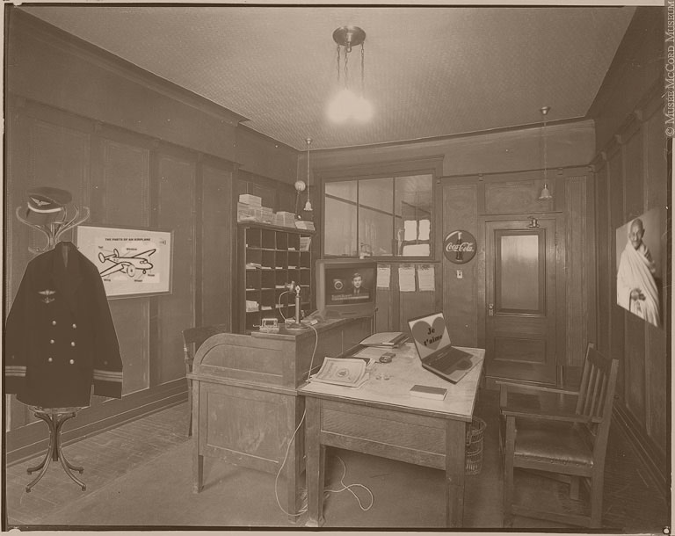
What’s wrong with this picture?
Can you identify eight anachronisms in this photo? Once you have found them all, associate each anachronism with a need in Maslow’s pyramid.
Identify the anachronisms using drawing tools in your word processing or drawing software. Click on “View,” “Toolbars” and “Drawing.”
You can enlarge the image to analyze it by clicking on “View,” “Zoom...” and “150%” or “200%.”

